WEEK 4 program_2_Bank Database

Find all the customers who have an account at all the branches located in a specific city (Ex. Delhi).

Sol.

Select D.customername

From depositer D, bankaccount BA, branch B

where D.accno=BA.accno and BA.branch_name= B.branch_name and B.branch_city='Delhi'

group by D.customername

Having count(distinct(B.branch_name)) =

(select count(branch_name) from branch where Branch_city = 'Delhi');

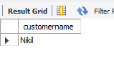

Find all customers who have a loan at the bank but do not have an account.

create table dhiksha_bank.borrower(

Customername varchar(20),

Loan_number int,

PRIMARY KEY(Customername, Loan_number),

foreign key (Customername) references BankCustomer(Customername),

foreign key (Loan_number) references Loan(Loan_number)

);

insert into borrower values("Avinash",1);

insert into borrower values("Dinesh",2);

insert into borrower values("Mohan",3);

insert into borrower values("Nikil",4);

insert into borrower values("Ravi",5);

select distinct Customername

from borrower where Customername not in

(select Customername from Depositer )

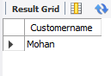

Find the names of all branches that have greater assets than all branches located in Bangalore.

select Branch_name from branch where assets > all

(select assets from branch where Branch_city ='Bangalore');



[The result grid shows null because Bangalore has the highest asset]

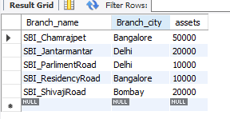

Find all customers who have both an account and a loan at the Delhi branch

select Customername from borrower, Loan where

borrower.Loan_number=Loan.Loan_number and

Loan.Branch_name in(select Branch_name from Depositer,

bankaccount where Depositer.accno=BankAccount.Branch_name

in(select Branch_name from branch where

branch.Branch_city="Delhi"));

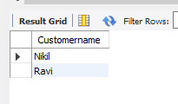

Demonstrate how you delete all account tuples at every branch located in a specific city (Ex. Bomay).

delete from BankAccount

where Branch_name IN (

select Branch_name

from branch

where Branch_city='Bombay'

);

select * from BankAccount;

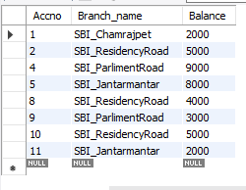

Update the Balance of all accounts by 5%

SELECT * FROM LOAN ORDER BY AMOUNT DESC;

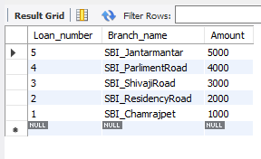

(SELECT Customername FROM Depositer ) UNION (SELECT

Customername FROM borrower);

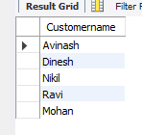

CREATE VIEW BRANCH_TOTAL_LOAN (BRANCH_NAME,

TOTAL_LOAN) AS SELECT BRANCH_NAME, SUM(AMOUNT) FROM LOAN

GROUP BY BRANCH_NAME;